North South University



Project Report

**Project Title:** Physical growth of urban areas of Bangladesh

**Course Code:** Env 203

**Semester:** Spring 2019

Submitted By: Submitted To:

**Ridwanul Haque Saiful Momen**

**ID: 172 1144 042 Initial: SMO**

**Section: 02**

**Submission Date: 17-04-2019**

**Bashurhat:**

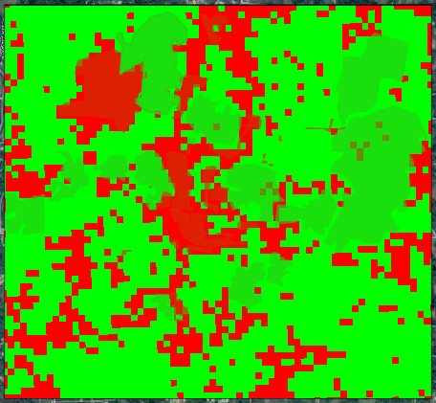Basurhat 2001

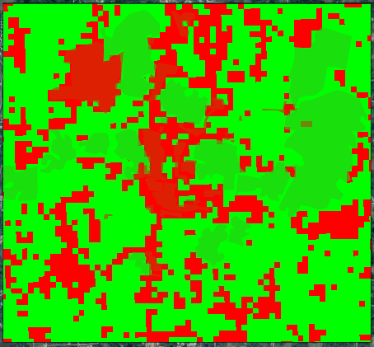**Basurhat 2011, population had slightly increased from 2001. Seems like natural growth of population of Bangladesh, no spatial cause.**

**Gaffargaon:**

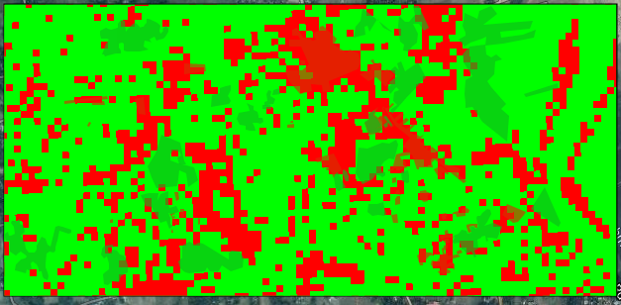

Gafargaon2001

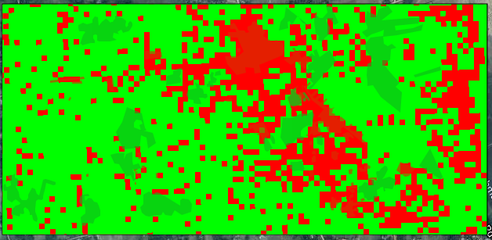

**Gafargaon2011, Population had increased in a certain area and decrease in other areas. Because of urbanization this kind of placement occur.**

**Sylhet:**

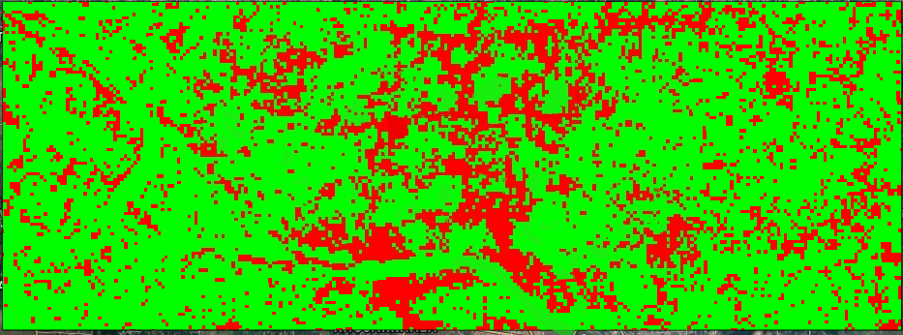

Sylhet 2001

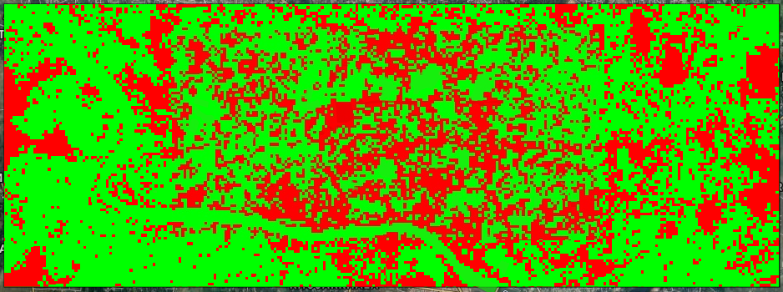

**Sylhet2011, every inch of Sylhet, there is population had increased. As a bit city as well as division, Sylhet is growing with it’s population, seems in the picture**.